The Tower of Angruvidal
Quest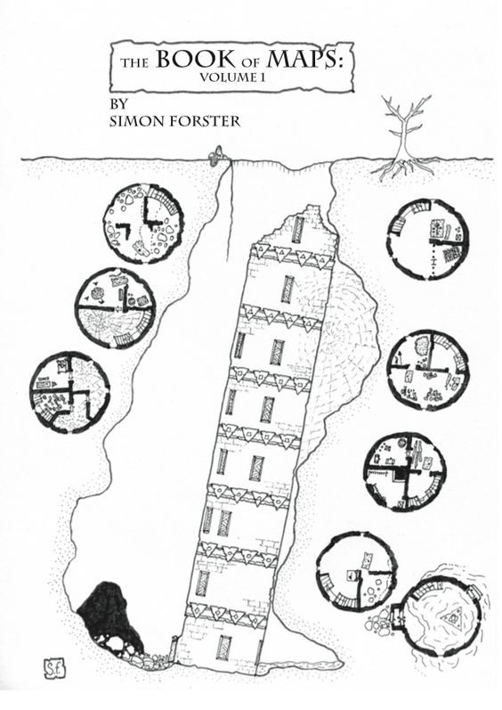
The ederman family is concerned about a wizard who has set up station by the old owl well, who has set to digging up the sight with swarthy orc men alongside him. They grew increasingly more concerned when they heard tales from the town wizard, Hellen Farspark, about an ancient civilization that was once set upon this very spot. One that almost brought about the distruction of all of the sword coast!
The family wants you to go there and remove the prying wizard by force.

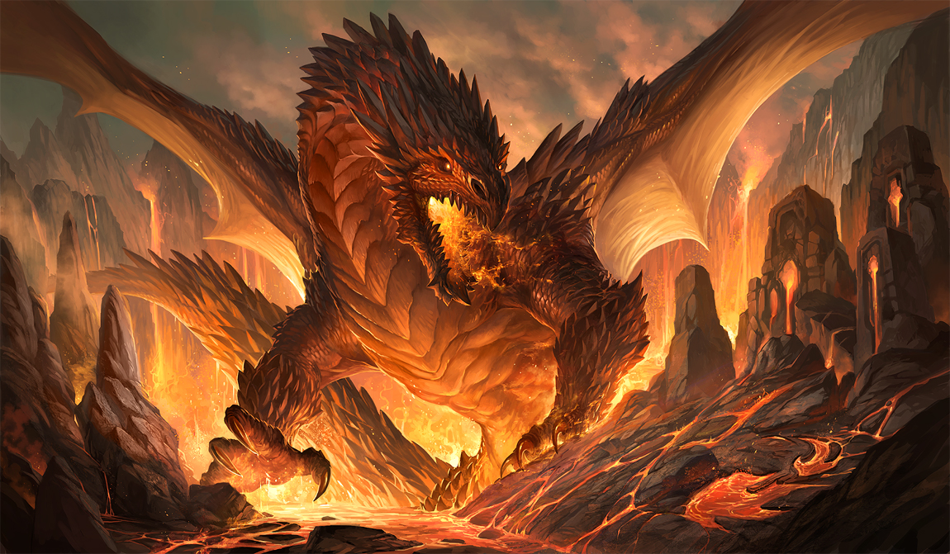Lore of Angruvidal, Lord of the Planes of Ceaseless Flame
Angruvidal was or is a powerful Firelord, and a prince on the planes of eternal fire. But having grown spiteful and greedy over the many years he decided to set his gaze upon the mortal Realms, having material wealth and a seemingly endless flow of fresh souls pooring out of it, he wished to control this realm. For Centuries he set plot and conspiracy to bring about his coming to our realm. He has convinced cults to worship him as a god, and be his mortal hands in this world. Seting in action the very components required to bring him to our world. For try as he might he could not be let into our plane of existance on his will alone. He needed a guide. A pathfinder if you would. Someone that would gather the magical forces required to give him a astral GPS to our plane of existance.
His heraldry was once almost complete were it not for the forces of The Great Lords from the plane of Water, Earth, and

NPCS
GOD DAMN IT I HATE THIS THIS SUCKS I JUST WANNA WRITE BUT MY HANDS AND MIND DON’T WANNA
BUT THEY DO WANNA TELL THIS STORY!!! FUCK MEEEEEEEEEEEE

