Mutated Fighter

Your martial development was forever altered when your flesh began to change, whether by accidental exposure, deliberate induction of mutation, or unknown means. Whereas others train their prowess and utilize rigorous training in conventional ways, you’ve learned to focus much of your development on seeking control of your mutable flesh gaining strength and other abilities to aid your martial might.

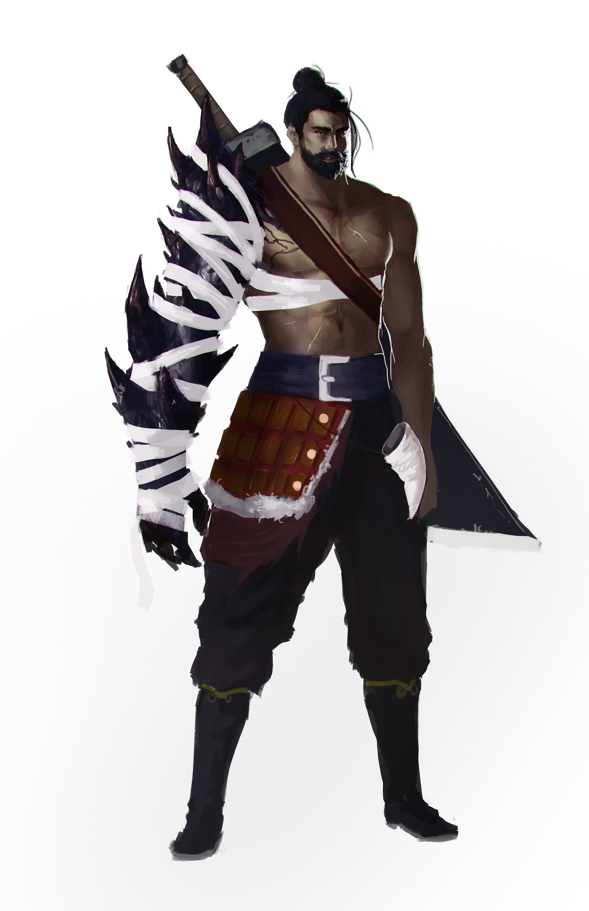

Touched by Mutation
You have begun to mutate and your inhuman form is terrifying for most to behold. You gain proficiency in intimidation or -If you were already proficient in it- you double your proficiency bonus when making intimidation checks. In addition, roll on the table below select a random mutation. (Alternately, work with your GM to figure out one for your character.)

A Selection of Possible Mutations
1 One of your limbs has grown huge and misshapen
2 Your skin is stretched and split by the places the flesh has grown too fast to be held.
2 Your eyes have become alien and strange.
3 You appear unnaturally gaunt and have permanently lost all body fat.
4 Your vocal cords have changed and you speak with a voice like a monster.
5 Your skin has changed color.
6 Your skin has changed texture: you are now covered in scales, hair, or even feathers.
7 Your fingers now end in clawed talons.
8 You have grown a tail.
9 You have grown an extra limb.
10 You have grown an extra eye or other sense organ.
11 Your limbs have changed so your joints fold the opposite way.
12 You have an elongated neck that allows you to telescope your head around.

Changing Flesh
When you choose this archetype at 3rd level, you gain a set of abilities that are fueled by special dice called mutant dice. You have four mutant dice, which are d4s. A mutant die is expended when you use it. You regain all of your expended mutant dice when you finish a short or long rest. You gain an additional mutant die at 7th level and one more at 15th level. You can expend mutant dice to gain a number of different benefits (note, once you have used a mutant die, you can not use another until the start of your next turn):
- Physical Power Surge: As a bonus action, choose either strength or constitution & roll mutant dice and add the results to the appropriate modifier. This effect lasts until the end of your next turn (hp gained this way are temporary) and changes your appearance (bulging muscles, skin covered in scales, ect).
- Twisted Flesh: By remapping your internal structures, you can use a reaction designate an alternate saving throw over the one called for by the GM. You are limited to substituting physical stats for one another or mental stats for one another: strength-dexterity-constitution can be substituted for one another or wisdom-intelligence-charisma may be substituted for one another. You must choose to use this ability before rolling your saving throw and this ability only works for a single saving throw you modified with your reaction and not additional ones.
- Regeneration: As long as you have at least 1hp, you may use an action to roll a mutant die. You regain that many hit points + your constitution modifier at the start of each of your rounds for a number of turns equal to your proficiency bonus.
- Armored Carapace: Sprouting thick scales, you can use an action to roll a mutant die to gain that amount in AC till the start of your next round.
- Elemental Resistance: Covering your flesh with hair or slime, you can utilize a bonus action to expend a mutant die to gain resistance to one type of elemental damage till the start of your next round.

Altered Physiology
At 7th level, you can cast Alter Self without the use Verbal or Somatic requirements. You regain the use of this ability after a short or long rest.

Empowered Mutations
At 10th level, your mutant dice turn into d6s. At 18th level, they turn into d8s.

Constant Change
Starting at 15th level, when you roll initiative and have no mutant dice remaining, you regain one mutant die.

