Man Hunter: Ranger

You specialize in hunting sentient humanoids, with a variety of tools and skills that allow you to infiltrate and catch your target or targets unaware.

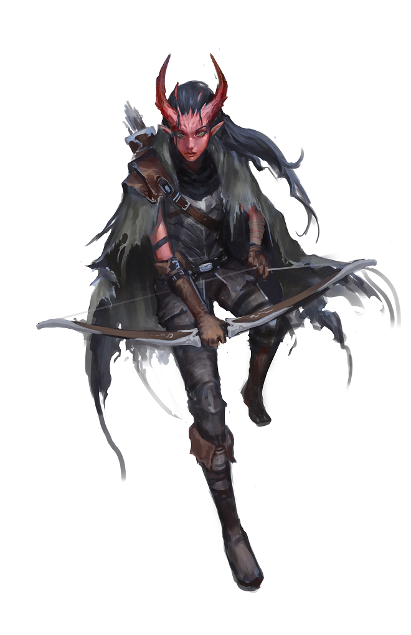

Manhunter Magic

You learn an additional spell when you reach certain levels in this class. The spell counts as a ranger spell for you, but it doesn't count against the number of ranger spells you know.
Ranger Level Spell
3rd Hunter’s Mark
5th Hold Person
9th Counterspell
13th Locate Creature
17th Mislead
Bonus Proficiencies
At 3rd level, you gain proficiency with any one of the following skills Deception, Insight, Investigate, Perception, Persuasion or Stealth as well as one of the following toolkits disguise kit, forgery kit, poisoner’s kit, or thieves tools.
Always on the Hunt
At third level, you can cast Hunter’s Mark (at the lowest level) as a bonus action without expending a spell slot. You may use this ability a number of times equal to your wisdom modifier until you complete a short or long rest. At 7th level, you have mastered this essential spell to the degree that you can simultaneously concentrate on another spell in addition to concentrating on Hunter’s Mark.

Watch and Understand
At 7th level, by studying a humanoid creature for one minute, you can determine their movement speed, what weapons they are proficient with, a single spell they are capable of casting (GM’s Choice), and their highest spell level. This ability works even if the target has used magical means to change their form or appearance.

Press Your Advantage
Beginning at 11st level, you’ve learned to press your advantages and strike more effectively when you have the opportunity. You can deal an extra 1d6 damage to a creature you hit with an attack if you have advantage on the attack roll.
This damage increases to 2d6 at 15th level, and 3d6 at 19th level.

Superior Ambushing
At 15th Level, you can’t be surprised in combat. In addition the first attack you make before your opponent has had a chance to act has advantage..

