Circle of Fungus: Druid

You’ve learned to commune with the creeping power of fungus, the mycological substrate that exists below and within every ecosystem. You gain powers over rot and death and rebirth, in bestowing or removing afflictions, and your wildshape sees your flesh reborn into a fungal body with the aid of the mushroom intelligence living within you.

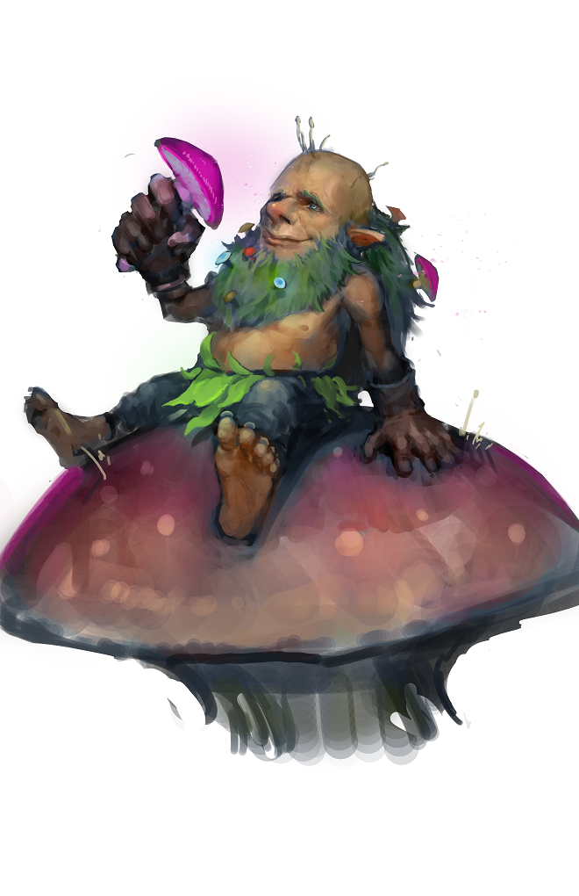

Circle Spells
At 2nd level, you learn the Spare the Dying cantrip. At 3rd, 5th, 7th, and 9th level you gain access to the spells listed for that level in the Circle of Fungus Spells table.
Once you gain access to one of these spells, you always have it prepared, and it doesn't count against the number of spells you can prepare each day. If you gain access to a spell that doesn't appear on the druid spell list, the spell is nonetheless a druid spell for you.

Druid Level | Circle Spells
3rd | Ray of Enfeeblement, Darkvision
5th | Speak with Dead, Bestow Curse
7th | Death Ward, Black Tentacles
9th | Cloudkill, Reincarnate

As your connection with the fungal substrate intertwining all nature, you begin to experience profound changes. Your Wild Shape form now allows you to have a fungal body, which grows in power and abilities over time.

Fungal Shape
At 2nd level, when you use your Wild Shape feature, you do not transform into an animal form and instead your body is modified and empowered by the fungal tendrils that run throughout your flesh and tiny invisible philia reaching out from your skin. When you activate this feature, you gain the following abilities:
-you gain blindsight 10ft.
-your reach goes up 5 feet
- Your movement speed goes down 5ft
Using your Wild Shape feature makes your body appeared to be comprised of strands of blooming fungus. As you become more comfortable with your altered form, your movement, blindsight, and reach increase an additional 5ft at 9th level, and an additional 5ft at 17th level.

Chitinous Weapon
Starting at 2nd level, while using your Wild Shape feature you can use a bonus action to create any weapon that you are proficient with. This weapon is made of fungus & hardened chitin and must be in your hands or will wither and dissolve into uselessness by the end of your next turn, though you are capable of making (and firing) useable ammunition this way.
At 6th level, this weapon is considered magical for the purposes of overcoming resistance and immunity to nonmagical weapons.

Fibrous Resistance
At 6th level, when you use your Wild Shape feature you have resistance to bludgeoning, piercing, and slashing damage from nonmagical weapons.

Digestive Restoration
At 10th level, while activating your wildshape feature or resuming your regular form, you can choose to remove one of your status afflictions or conditions as per the lesser restoration spell.

Fungal Cloud
At 14th level, as a bonus action you summon a stinking cloud (as per the spell, save is your spell save DC) with the following modifications: the cloud lasts for 1 minute and for that duration it remains centered on you & moves with you, you can see through this cloud without difficulty, and you are otherwise immune to its effects (ie being within it doesn’t require a constitution save from you). You can dismiss this cloud as a bonus action.

Once you use this ability, you can not use it again until you finish a short or long rest.

