Salt in Wounds Bestiary
  - By J.M. Perkins

Contents
Salt in Wounds Bestiary 1
Introduction 3
Monsters of Salt in Wounds 4
Ramora Fleas 5
Dwergo Alchemical Revenant 6
Torture Fey 7
Alchemist Testing Apparatus 8
Clot 9
Tarrasque Flesh Golem 10
Pain Fey 11
Pain Fey Lord 12
Hatchet Beak 13
Glass Shard Slime 14
Infiltrex Harpy 15
Saved 16
Thousand Quill 17
Carrion Beatle 18
Torrent Worm 19
Skalandile 20
Quirsme 21
Blood Crystal Husk 22
Blood Crystal Servitor 23
Blood Crystal Pyramid 24
Masked One 25
Cloaked Void 26
Skin Flay Mummy 27
Half-Formed Jolly 28
Jolly 29
Marrow Fox 30
Scroll Golem(?) 31
Angel Bloom 32
Emporer Toad 33
Ledgerman 34
Flash Spider 35
Red Leach Tide 36
Dessication Goblin 37
Vat Golem 38
Imprinted Armor 39
Ur-Tarrasque 40
Skeletal Phalanx 41
Sieve Slave 42
Pact-Failed 43
Manumission Revenant 44
Trollkin Mammoth 45

Introduction

Monsters of Salt in Wounds

Ramora Fleas

Dwergo Alchemical Revenant

Torture Fey

Alchemist Testing Apparatus

Clot

Tarrasque Flesh Golem

Pain Fey

Pain Fey Lord

Hatchet Beak

Glass Shard Slime

Infiltrex Harpy

Saved

Thousand Quill

Carrion Beatle

Torrent Worm

Skalandile

Quirsme

Blood Crystal Husk

Blood Crystal Servitor

Blood Crystal Pyramid

Masked One

Cloaked Void

Skin Flay Mummy

Half-Formed Jolly

Jolly

Marrow Fox

Scroll Golem(?)

Angel Bloom

Emporer Toad

Ledgerman

Flash Spider

Red Leach Tide

Dessication Goblin

Vat Golem

Imprinted Armor

Ur-Tarrasque

Skeletal Phalanx

Sieve Slave

Pact-Failed

Manumission Revenant

Trollkin Mammoth

Kolo Bird CR 2

This dark-feathered bird has a red undertail and intense yellow eyes, and its hooked beak is congealed with gore.
XP: 600  N Tiny animal  Init +4; Senses low-light vision, keen carrion sense; Perception +7  DEFENSE  AC 16, touch 15, flat-footed 13 (+2 size, +3 Dex, +1 natural)  HP 20 (3d8+6)  Fort +5, Ref +6, Will +4; +4 vs. disease  OFFENSE  Speed 10 ft., fly 40 ft. (average),  Melee bite +7 (1d4 plus wounding and blood hunt)  Space 2-1/2 ft.  Special Attacks wounding, blood hunt | 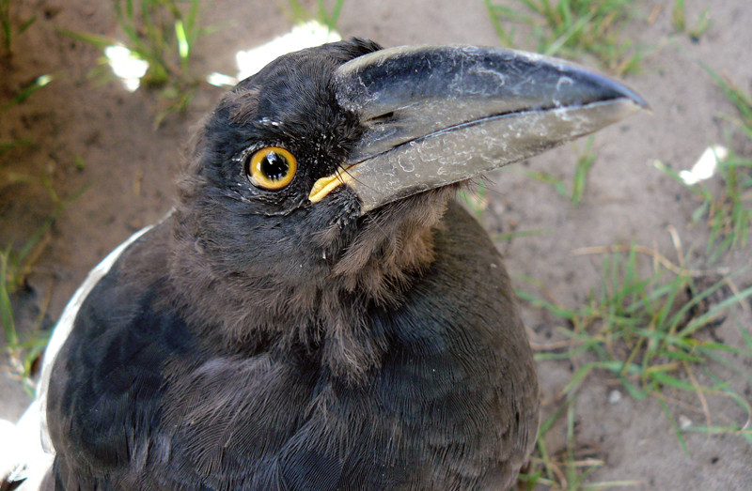  Placeholder art
STATISTICS
Str 10, Dex 17, Con 14, Int 2, Wis 17, Cha 7
Base Atk +2; CMB +0; CMD 13
Feats Improved Natural Attack (Bite), Weapon Finesse
Skills Fly +8, Perception +7, Survival +11
Racial Modifiers +8 to Survival
ECOLOGY
Environment any land
Organization solitary, pair, wake (20–100), or raid (80–1000)
Treasure None

SPECIAL ABILITIES
Blood Hunt (Ex) Whenever a kolo bird successfully damages a creature with blood, all kolo birds within 60ft gain a +1 circumstance bonus to hit and damage against the injured creature for 3 rounds. Each successful attack refreshes this bonus.

Keen Carrion Sense (Ex) Kolo birds can sense undead and badly wounded creatures (50% or fewer hit points) by scent (as per the special quality) in a 180-foot radius and can detect dying creatures (as per the condition) of size Large or larger at ranges of up to a mile, ignoring surface conditions and poor visibility.
Wounding (Ex) The incredibly sharp beak of a kolo bird functions as a wounding weapon, dealing 1 point of bleed damage per hit. Bleeding creatures take the bleed damage at the start of their turns. Bleeding can be stopped by a DC 15 Heal check or through the application of any spell that cures hit point damage. A critical hit does not multiply the bleed damage. Creatures immune to critical hits are immune to this bleed damage.

Kolo birds are micropredators, using their incredibly sharp beaks to create nesting cavities. After excavating a home, they use their keratin secreting undertails to create stable, undermining wounds inside the host creature while they delve deeper to nutritious organs. The regenerative properties of the Tarrasque has caused a colony of kolo birds to thrive in Salt-in-Wounds, serving as a massive hive for the once rare creatures.
Kolo birds are large and slender, averaging just over 2 ½ feet in length with a wingspan of 3 feet, with an average weight of around 1 pound. A spellcaster of at least 7th level who has the Improved Familiar feat may select a kolo bird as a familiar.
Ecology
The carnivorous kolo bird does not typically hunt. Rather, they rely on their keen carrion sense to scout for wounded creatures, preferring to deliver a coup de grace rather than drawn out conflicts. When attempting to nest, kolo birds seek out megafauna, using their beaks to create a cavity roughly 3 inches high for them to tunnel into. Once inside, kolo birds lay up to two eggs before squeezing back out of the wound to fly away. These eggs are covered in tiny hair-like transporters for anchoring and drawing parasitic nutrition. During the gestation period, the megafauna is followed by a pairing or wake of kolo birds, serving as sentry for the host. Keen eyed trophy hunters are quick to spot the tell-tale signs of kolo bird implantation- “punched out” wounds with rolled back lips, while the careless are often found bled and torn to shreds after attempting to harm the chosen host. This symbiotic relationship ends after a month, after which the kolo hatchling tunnels out of the megafauna in non-lethal fashion.
Habitat and Society
While the largest congregation of kolo birds reside in Salt-in-Wounds, they are not native to the area. Before the subjugation of the Tarrasque, kolo birds were rarer in Synoma, found mostly in temperate areas where megafauna capable of incubating their young. As the Red River continues to spread it's infection, more and more kolo birds began to sense the Tarrasque, causing them to flock to the wounded kaiju. With an unlimited food source and little predators to speak of, the kolo birds have thrived.
Given their natural resistance to disease and mutation, kolo birds are often served as “squab skewers” in the stalls of The Throat, noted for having a tough, irony taste. Some Meridian Houses have converted dovecotes to serve as living pantries for kolo birds, feeding them a specialized diet and slaughtering them at one month to increase tenderness and flavor. A small group of Monad alchemists are also researching practical uses for kolo bird keratin to treat bleeding wounds (as per bloodblock, PRG: UE pg. 102).

Other Kolo Birds
Dire kolo birds called “Watchers” given their intense eyes, have resulted due to a steady diet of Tarrasque. These birds are more aggressive and deadly than their smaller cousins, leading bounty hunters to train them to pursue bounties and track viscera smugglers. Watchers stand about 4 feet tall with a wingspan of close to 10 feet, with an average weight of 20 lbs.
WATCHER COMPANIONS
Starting Statistics: Size Small AC +2 natural armor Speed 10 ft., fly 40 ft. (average) Attack bite (1d6) Ability Scores Str 10, Dex 13, Con 14, Int 2, Wis 17, Cha 7 SQ low-light vision, keen carrion sense, blood hunt
7th-level Advancement: AC +2 natural armor Ability Scores Str +4, Dex +2, Con +2 Special Attacks wounding (as per watcher ability; see below)
Watcher (Dire Kolo Bird) CR 3
More mottled than it's smaller cousins, the Watcher kolo bird sports a massive beak and minor vestigial mutations
XP: 800  N Small animal  Init +3; Senses low-light vision, keen carrion sense; Perception +7  DEFENSE  AC 18, touch 13, flat-footed 15 (+1 size, +2 Dex, +4 natural)  HP 28 (3d8+15)  Fort +7, Ref +5, Will +4; +4 vs. disease  OFFENSE  Speed 10 ft., fly 40 ft. (average)  Melee bite +9 (1d6+2 plus wounding)  Space 5 ft.  Special Attacks wounding, blood hunt | 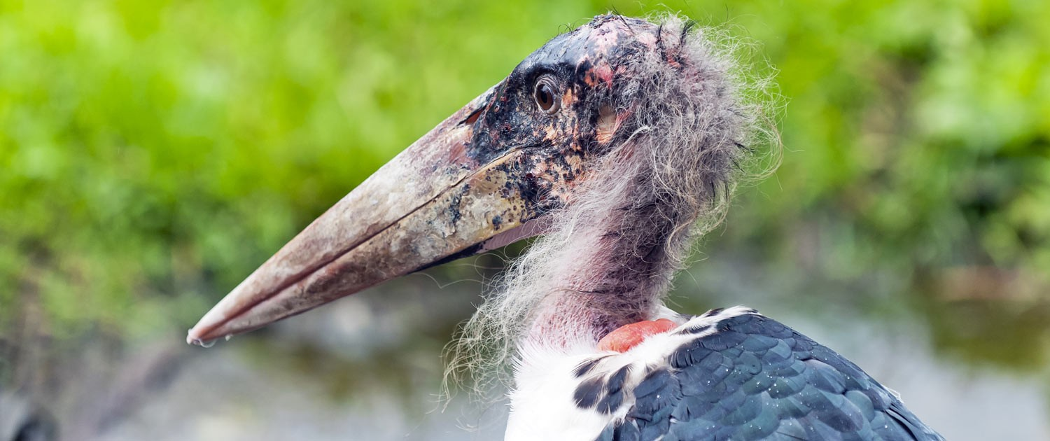  Placeholder art
STATISTICS
Str 14, Dex 15, Con 18, Int 2, Wis 17, Cha 7
Base Atk +2; CMB +3; CMD 15
Feats Improved Natural Attack (Bite), Weapon Finesse
Skills Fly +5, Perception +7, Survival +11
Racial Modifiers +8 to Survival
ECOLOGY
Environment any land
Organization solitary, pair, or wake (20–80)
Treasure None

SPECIAL ABILITIES

Blood Hunt (Ex) Whenever a kolo bird successfully damages a creature with blood, all kolo birds within 60ft gain a +1 circumstance bonus to hit and damage against the injured creature for 3 rounds. Each successful attack refreshes this bonus.

Keen Carrion Sense (Ex) Kolo birds can sense undead and badly wounded creatures (50% or fewer hit points) by scent (as per the special quality) in a 180-foot radius and can detect dying creatures (as per the condition) of size Large or larger at ranges of up to a mile, ignoring surface conditions and poor visibility.
Wounding (Ex) The incredibly sharp beak of a kolo bird functions as a wounding weapon, dealing 2 points of bleed damage per hit. Bleeding creatures take the bleed damage at the start of their turns. Bleeding can be stopped by a DC 15 Heal check or through the application of any spell that cures hit point damage. A critical hit does not multiply the bleed damage. Creatures immune to critical hits are immune to this bleed damage.

