Cupid’s Sparrow

Macintosh HD:Users:narciss:Desktop:000 DND_ASSETS:DnD SHARDS:DnD_shard.eps

A Valentine’s Day-themed adventure for pairs and parties

**Credits and Acknowledgements**

Thank you to our friends Eric and Gia for playtesting and giving us feedback!

Thank you to Matěj Čadil whose art graces the cover, See more at http://www.angrenost.cz/angrenost.php

Thank you to Spasibenko Art and Beck McCormick on Creative Market for “Watercolor Forest Plants” and the “Farmhouse Country Rustic Script” respectively.

Thank you so much to the Mistress of Maps, Deven Rue of rueink.com. Her fonts beautify this text.

Thank you to Michael Taylor of cryrid.com/digitaldnd for the Stat Blocks and generally being awesome.

A brief adventure for one or more players of any level and their DM



DUNGEONS & DRAGONS, D&D, Wizards of the Coast, Forgotten Realms, the dragon ampersand, *Player’s Handbook, Monster Manual, Dungeon Master’s Guide,* D&D Adventurers League, all other Wizards of the Coast product names, and their respective logos are trademarks of Wizards of the Coast in the USA and other countries. All characters and their distinctive likenesses are property of Wizards of the Coast. This material is protected under the copyright laws of the United States of America. Any reproduction or unauthorized use of the material or artwork contained herein is prohibited without the express written permission of Wizards of the Coast.

©2016 Wizards of the Coast LLC, PO Box 707, Renton, WA 98057-0707, USA. Manufactured by Hasbro SA, Rue Emile-Boéchat 31, 2800 Delémont, CH. Represented by Hasbro Europe, 4 The Square, Stockley Park, Uxbridge, Middlesex, UB11 1ET, UK.

**A Celebration of Love**

Health potions are red

Knife blades are too,

On Sune’s Day you’ll see

If the one you love is true

* Local proverb

# Introduction

**As is well known**, once a year, a few weeks before the spring solstice, a festival is held in honor of the goddess Sune, celebrating love and beauty and beseeching her blessings throughout the year. A little more than a century ago, the Sunite priestesses received a message from their goddess: on this day, she would be most pleased if the people of the Realms would honor her by expressing their love and affection to one another, spending time with those they care for, and exchanging small tokens of admiration.

The relative prosperity of each populace alongside the character and number of dining and drinking establishments affect the spirit and tenor of Sune’s Day celebrations. For most, the evening consists of a tavern meal, music, and the treat of a finer wine or ale, with perhaps the exchange of a small present, either hand-crafted by the giver or carefully selected from a merchant or artisan.

Adventurers strive to map out their travels in such a way that they can pass through a small town or larger urban center for Sune’s Day to enjoy the late-winter decorations of hardy flowers and beautiful vines and to leave candles or small gifts at the temples to hasten the coming of spring.

# Overview

Cupid’s Sparrow is designed to be dropped into any campaign setting for a quick, fun, and possibly romantic diversion. This adventure includes scripted text to make it easy for the DM. However, the majority of the fun in this scenario will come from going off-script and rolling on the random tables, allowing chance and the players to take the evening where they will.

As the adventure opens, the player(s) stroll into town and enjoy the sights as the small village prepares a festival in honor of the goddess Sune. The night takes an odd turn upon entering the Lover’s Nook Inn, where an acolyte has tainted the tavern’s libations with an unpredictable Philter of Love. The party can find the misguided Cupid in the cellar of said establishment.

Appendix A includes the tables for simulating the evening’s shenanigans. Appendix B contains a map of the town as well as a map of the Lover’s Nook Inn and its cellar.

Boxed text is meant to be read aloud. The DM should also consider sharing the Introduction text if it works for their setting.

# Background for the DM

For the past several years, a sweet but addled cleric of Sune, nicknamed Cupid, has been manipulating love potions in various experiments, hoping to monetarily benefit the local clergy. He was discovered by a horrified priestess who was warned in a vision of the goddess’s displeasure. Attempting recompense, Cupid has devised a plan for his goddess’s special holiday.

Misunderstanding much of the problem with his last endeavors, the cleric’s plan to win back Sune’s favor closely resembles the indiscretion that lost it in the first place. He has devised a potion that can be distributed to all the townsfolk that will open hearts and allow for the free and unfettered expression of love.

Had Cupid been successful in his experiment, the night would still be progressing in a strange fashion but, unfortunately for those visiting The Lovers’ Nook, the potion proportions are not quite right, causing a myriad of random effects to be unleashed throughout the inn, resulting in mayhem and surprise.

It may go down in history as the town’s most interesting Sune’s Day yet.

# The Adventurers Arrive in Town

Due to either careful planning or fortunate mishap, you find yourself and your adventuring party at the edge of a small town just after midday before the Sune’s Day celebrations begin in earnest. You are all somewhat tired from your journey but also energized by the promise of the evening ahead.

Making a few inquiries around town in the late afternoon, many recommendations point you in the direction of the village inn, The Lovers’ Nook, where you can share a meal and be graced by the finest bards the countryside has to offer. With slight trepidation but without a better option, you and your party settle on dinner (and maybe dancing) at The Lovers’ Nook.

You each spend the afternoon on secretive errands of present-getting and getting ready for the night’s revelries before reconvening at the inn.

### Refer to the Table of Presents and Preparation

If the adventurers aren’t sure of what they might want to try to purchase for one another or of what they’d like to do around town. Refer to Appendix B for a map of the town if you so desire. We’ve included both a labeled and an unlabeled version for printing, so you can run the adventure through a preexisting town or a new one.

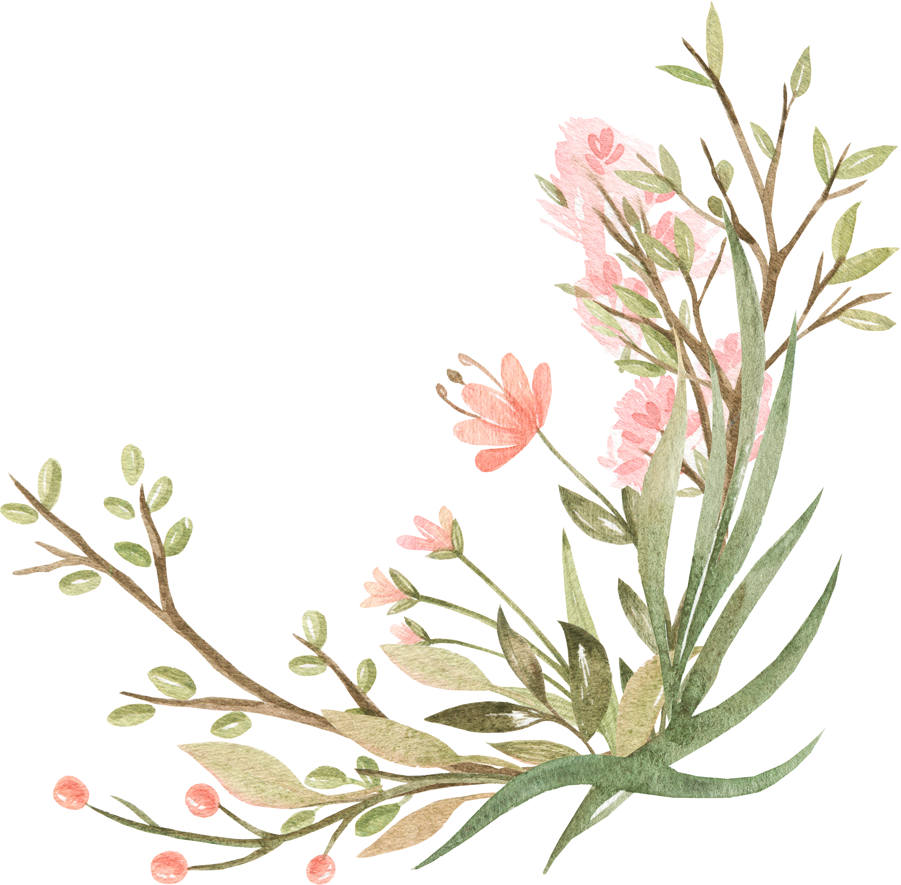

# Walking to the Inn

A few short hours after sundown, the town streets are awash in the glow of lanterns and candles strung about in homage to the goddess of love and beauty. You begin your walk to the inn to meet up with your party/date. The crisp night air causes small groups and pairs to cluster together on the town streets as they decide where to spend their evening. In these warmth-seeking moments, a member of the party often gestures overhead, admiring the swinging lanterns that add a magical air to the quaint, picturesque scene.

You wind through the streets, recalling the multiple sets of directions you received in the afternoon. The inn itself is not hard to find, and the exterior is quite beautiful. It blends in well with the village’s aesthetic, sitting just outside the town proper at the edge of a picturesque forest. Standing a story taller than most of the local establishments, soft, warm light glows from the full, frosted windows of the lower floor, beckoning townsfolk and travelers in out of the cold.

A line stretches out from the front of the inn, small groups of two, three, and four pressed together, eagerly chatting over their plans for the evening and generally expressing their thankfulness for the time spent together. They wave to passersby they know well, occasionally dashing across the street to exchange a hug or well wishes.

You take your place at the end of this line, craning your neck slightly in hopes of spotting the rest of your party either ahead of you or hurrying toward you down the street. To your relief, a few minutes after your arrival, your date arrives, slightly flushed, but beaming.

Inn Employees and descriptions

Josephine—seating hostess and greeter, human woman, brunette with warm, olive-toned skin, pleasant but somewhat shy and not excessively chatty

Savina—gorgeous, curvy bartender with strawberry blonde hair braided with flowers and greenery, elven woman, early 400s, she enjoys company and light flirtation with the inn’s visitors, but she has little patience for those who tip poorly and try to take up excessive amounts of her time

Quint—half-elf with a ready smile and a gorgeous baritone voice, alternatively husky and pleadingly sweet, he’s especially interested in charming the female patrons with romantic melodies and the occasional wink

Mildred and Henry—the somewhat stressed owner of The Lovers’ Nook and her orange and white cat; she prefers quieter environments, and her unexpectedly popular inn’s additional surge of guests for Sune’s Day taxes her reticent demeanor

Ruus—young halfling field hand with shaggy blonde hair whose crush on Josephine makes him a little distracted but also over-eager to offer more help than he necessarily has license to give; his family wouldn’t like it, but he has high hopes of transitioning into the inn’s permanent staff so as to more regularly have opportunities of wooing the hostess.

# Anticipation

A nervous excitement pervades your first several minutes of reconnection. Expectations for Sune’s Day often run high, even for the most resolute or cynical. A short time after, however, ease and comfort return, and you pass your time outside together happily and comfortably. Almost to the entrance now, you can see the red and pink flowers the groundskeepers have intertwined with the charming ivy that arcs over the doorway and up the stone cobbles of the inn’s outer walls.

Josephine, a young human woman with hazel eyes and a shy, pleasant demeanor greets you and your party inquiring after your evening around the town, your recent adventures, and any special Sune’s Day traditions you celebrate. With a subtle twinge of embarrassment, she asks if you will be desiring a room after your dinner. It appears she’s gotten a few uncomfortable answers to that question over the course of the evening and is trying to be careful but thorough.

# On the Inside

Josephine excuses herself and steps inside to see if a table has been cleared for you and your party. She reemerges after a few minutes, smiling, and graciously invites you indoors.

The magic and romance of the decorations in the picturesque city have been beautifully translated to the inn’s interior. The wooden chandeliers with hanging lanterns are draped in ivy and white flowers, and each tabletop is graced by low bouquets of dark red roses and peonies and the glow of pink and white candles on small golden trays. The smell of baked bread wafts out from the kitchen, complemented by the scents of mulled wine, fruits, and cheeses.

Josephine leads you past several wooden tables, some with lovers sitting closely together, whispering and flirting, others with groups of friends laughing loudly and sharing plates of food and rounds of drinks.

She seats you a bit out of the way, explaining that you’ll be shielded from the draft and better able to hear the bards over here. At present, three of the minstrels are taking a break and having some watered-down wine in-between their rounds of the diners; a fourth sits strumming his lute quietly, the notes rising and falling just below the hum of patrons and waitstaff.

Josephine asks for the party’s drink orders, leaving them with a romantic-themed menu to glance over while she goes to the bar. ***Menu attachment included with downloads.***

**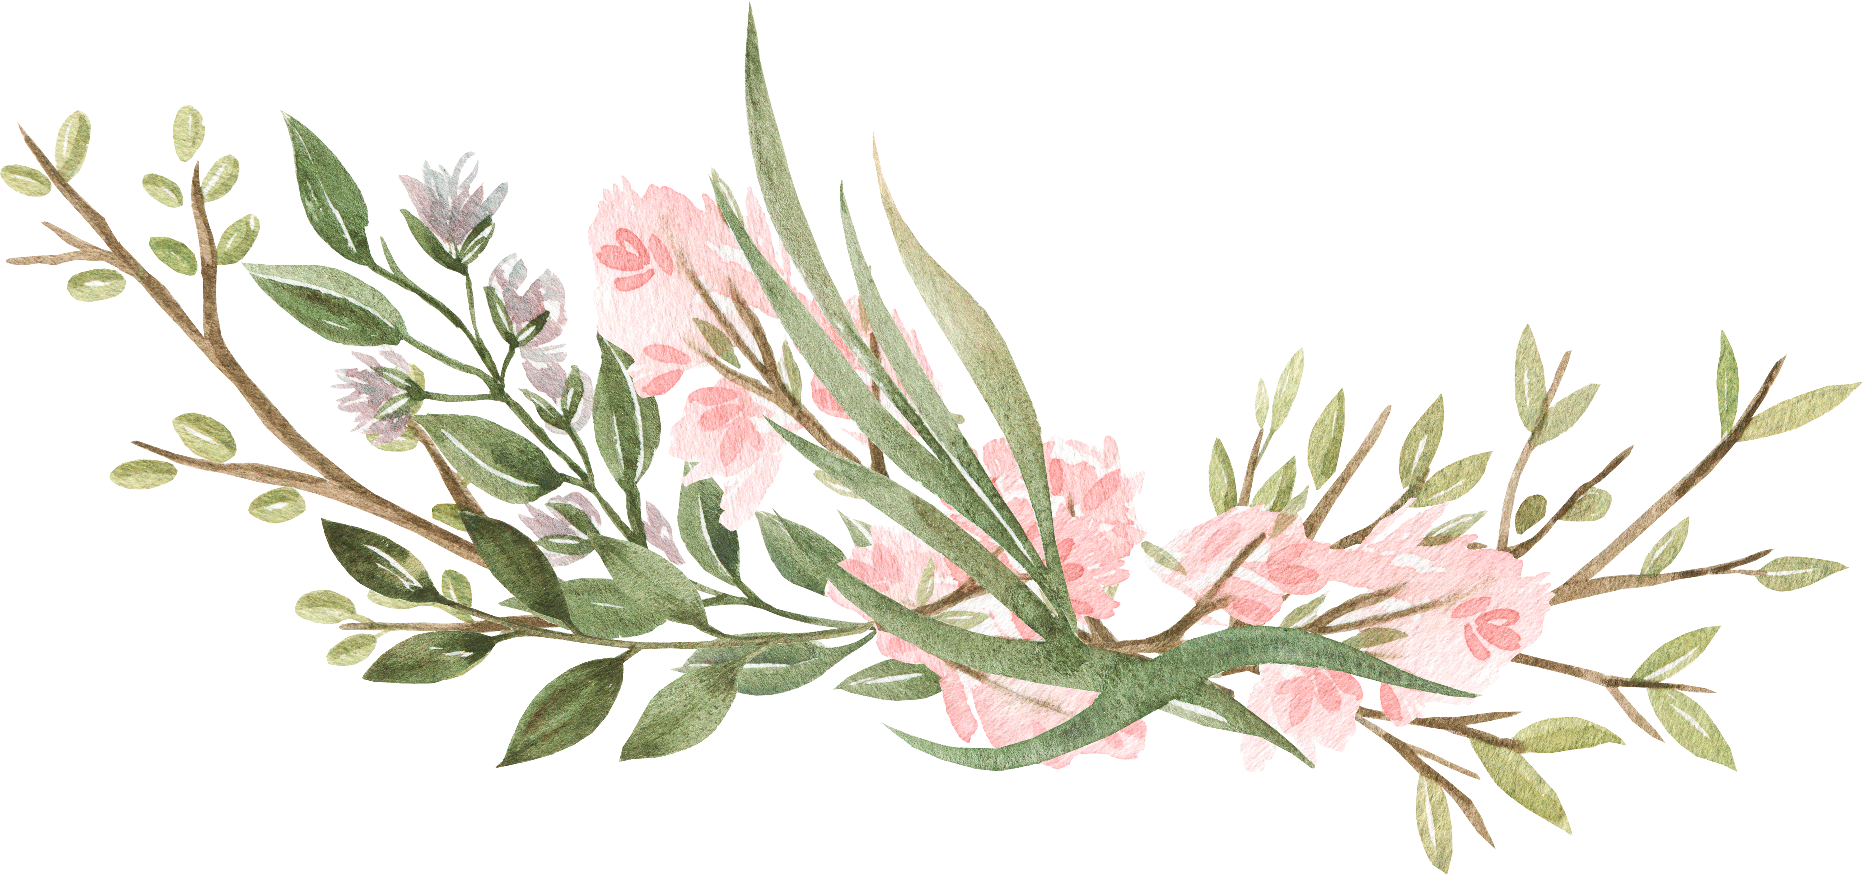**

**Philter of Love #9**

Love of Sune, I’ve found, expresses itself almost as love for life itself. There’s a thirst, a hunger, a deep-abiding desire to experience, to find, to be a living, breathing beauty. And that is why I follow her so fully.

* Mirelle Levura, light domain cleric of Sune

At this point in the evening, things are very much up to the dice and the DM. Allow the player(s) to RP. The Lover’s Nook should slowly descend into chaos and weirdness around the characters as more and more townsfolk fall under the effect of Cupid’s love potion silliness.

How much you make the player(s) aware of what is happening around them should depend on the stage of the evening as well as how the social interactions are developing. If there are lulls in the roleplay, feel free to move the action forward with a roll on the Random Effects and Events Table in Appendix A.

Incorporating Random Tables

And now for Cupid’s fun! At DM’s discretion, the party can make Constitution saving throws (suggested DC 15) or simply become intoxicated and wooed by the batch of love potion gone wrong. We’ve included four tables for these effects in Appendix A, including a table to help decide which of the random effects tables should be rolled on. If you’d prefer the adventurer(s) to follow the effects in order (accents, sudden love, interruptions, and gifts), they are arranged to make it easy to do so. If you have a larger party, it might be enjoyable to print off the tables and separate the different effects so that you can hand them out without having to state exactly what’s going on, allowing for more mystery and levity as they work toward discovering the source of the problem.

# Example introductions for random effects

### Accents and Voices

A thick, throaty voice you have not heard before this evening catches your attention, rising slightly above that of the others gathered in the inn. They stop mid-sentence for a bout of coughing and attempt to continue, their voice growing louder, but sounding increasingly confused. As you take a sip from the crisp ale Savina has just placed in front of you and turn to address your companion(s), a strange, unfamiliar voice slips out, expressing your words with a quite unexpected sound.

### Sudden Love

A seemingly drunken human man in his early thirties saunters over and leans against your table. He makes eyes at you and, as sexily as he can manage, invites you to follow him to the bar for a drink and conversation. Surprised, you take a sip of your wine to stall for time and prevent an overreaction from the other *slighted member* or *surprised members* of your party. In that moment, someone new catches your eye, and you find yourself unable to look away.

### Random Interruptions

The Sune’s Day evening doesn’t seem to be going the way anyone anticipated. Fistfights between abandoned partners are certainly not a common occurrence, especially multiple times in the same evening. However, the excitement reaches new heights when…

### Surprise Gifts

Unnoticed by the other member(s) of your party, you managed on the way in to slip a gift to Josephine to bring over with the dessert course. It is a beloved and honored tradition of Sune’s Day to surprise partners and friends with small tokens, and you are particularly pleased with your subtlety and sneakiness. They probably haven’t even noticed you closely watching the hostess! You catch a gasp of excitement before it leaves your lips as she approaches, eyes darting quickly over toward your date. Josephine gives you a wink and places a present in front of your attractive companion. However, what she leaves in her wake is not at all what you had planned for.

# Closure

After 3-5 rounds/rolls on the random tables, call for a Wisdom (Perception) check from the party member with the highest Passive Perception. If this character does not succeed on the DC 15 check, roll once more on the random events table before revealing the following information.

On a successful check, the party member notices a sparrow perched in the rafters looking at the proceedings in the inn with an unsettling aura of intelligence. The sparrow will notice that it has been discovered and flit away. If the party doesn’t give chase, it returns and shenanigans continue.

If the party does follow the sparrow, it leads them through the kitchens, down the back stair, and into the cellar. There’s one final obstacle the party must navigate in order to discover Cupid; they are stopped and questioned by one of the inn’s employees and can only make it past them by appealing to that person’s specific sensibilities.

Rolling on the *Table of Suspicious Employees* will randomize which employee spots them en route to the cellar.

There is also an outside entrance to the cellar if they wish to investigate on their own and don’t see the bird, but they could still be stopped by someone heading down there themselves in order to switch out a keg or fetch a barrel of wine.

# Mischief in the Cellar

In the cellar, poorly hidden behind the wine rack, a somewhat rotund man who is draped in pink robes and doesn’t seem to realize, given his haircut, that he is going slightly bald, quickly tries to hide his collection of vials behind his back at the sound of someone’s approach. He responds to threats with tears, but his fervor for Sune leaves him open to confessing his accidental misdeeds if he believes that he’s found a group of understanding co-conspirators.

### Cupid

Male human cleric, Chaotic Good

late 40s, fat and balding with rosy cheeks and a jolly attitude, drunk, barely wearing clerical robes

**Ideal:** Sune’s beauty, love, and radiance should be shared with everyone.

**Flaw:** Folks should understand Sune’s love regardless of if they are ready to accept it willingly. Also, alcohol.

Cupid is startled by anyone approaching him in the cellar. He is quite drunk and does not notice anyone until they call out or touch him. The smell of alcohol emanates off of him in waves. He can relay the following information.

* He has been down here since getting reprimanded and place on probation for attempting to sell Philters of Love. To make amends, he is giving the love potions away freely via the Inn’s booze stores.
* He may have messed up the measurements of the latest batch, causing some undesirable effects.
* The love potions should wear off in the next few hours.

He will be interested in paying recompense to the Lover’s Nook employees and owner. However, he does not want to be taken to the temple and will lash out at any character insisting such a course.

It is not expected that the player(s) fight Cupid, but if they do, he has these stats.

|  |  |  |  |  |  |  |  |  |  |  |  |  |  |  |  |  |  |  |  |  |  |
| --- | --- | --- | --- | --- | --- | --- | --- | --- | --- | --- | --- | --- | --- | --- | --- | --- | --- | --- | --- | --- | --- |
| **Cupid (Life Domain Cleric of Sune)**  *Medium male human, Chaotic Good*     |  |  |  | | --- | --- | --- | | **Armor Class** | 11 | *(Padded arnor)* | | **Hit Points** | 24 | *(3d8+6)* | | **Speed** | 30 |  |   C:\Users\Jonathan Ball\AppData\Local\Packages\Microsoft.Office.OneNote_8wekyb3d8bbwe\TempState\msohtmlclip\clip_image001.png     |  |  |  |  |  |  | | --- | --- | --- | --- | --- | --- | | **STR** | **DEX** | **CON** | **INT** | **WIS** | **CHA** | | 16 (+3) | 11 (+0) | 15 (+2) | 9 (-1) | 14 (+2) | 13 (+1) |   C:\Users\Jonathan Ball\AppData\Local\Packages\Microsoft.Office.OneNote_8wekyb3d8bbwe\TempState\msohtmlclip\clip_image001.png  **Skills:**History +1, Medicine +4, Persuasion +3 **Senses:** Passive Perception 12 **Languages:** Common, Celestial **Challenge:** 1/2  C:\Users\Jonathan Ball\AppData\Local\Packages\Microsoft.Office.OneNote_8wekyb3d8bbwe\TempState\msohtmlclip\clip_image001.png    **Charm.** On Sune’s Day, on Initiative count 20, Cupid can attempt to charm a creature he can see. The targeted creature must succeed on a DC 12 Wisdom Saving Throw or be charmed for one minute.  C:\Users\Jonathan Ball\AppData\Local\Packages\Microsoft.Office.OneNote_8wekyb3d8bbwe\TempState\msohtmlclip\clip_image001.png  **Actions**   * **Mace.** Melee Weapon Attack: +3 to hit, reach 5 ft., one target.   *Hit:* 6 (1d6 + 3) bludgeoning damage.   * **Spiritual Weapon, Mirror of Sune.** Ranged Spell Attack, Bonus Action: +2 to hit, range 60 feet, one target.   *Hit:* 6 (1d8 + 2) force damage.  C:\Users\Jonathan Ball\AppData\Local\Packages\Microsoft.Office.OneNote_8wekyb3d8bbwe\TempState\msohtmlclip\clip_image001.png **Reactions**   * **Panic Toss.** Cupid pulls a handful of pink sand out of his pocket and tosses it towards a creature making an attack. The sand follows the effects from the Wild Magic table, affecting either the cleric or the PC. |

**Appendix A**

# The Table of Presents and Preparation

|  |  |
| --- | --- |
| d6 | Presents and Preparation |
| 1 | A lovely bathhouse catches your eye. You spend an hour having a long soak and another getting a massage. They give you a bouquet of white flowers on your way out as a token of goodwill in honor of the holiday. You smell lovely and feel relaxed and refreshed. |
| 2 | You get a bit turned around on the way to the chocolatier. Seeking respite from the sudden chill outdoors, you wander into a pet shop where they’ve just found a small litter of wolf puppies in need of homes. The young half-elf running the shop looks at you with eager blue, gold-flecked eyes. Won’t you help her find them a home? |
| 3 | As you’re scouting about town for Sune-shaped pastries, you accidentally happen upon two lovers in a quarrell. Apparently one left the other in a compromising position away from civilization, causing a reasonable amount of alarm on behalf of the abandoned party. They catch you eavesdropping and ask for your advice, offering to buy you a drink if you’ll sit and counsel them. It’s not going to be a fast conversation, but they are very close with the confectioner and can get you an amazing discount. |
| 4 | Tucked away in a corner of the town, a small stone structure with a green banner catches your eye. Its unassuming stone facade invites you in, scores and scores of books greeting your eyes, crammed all about the shelves, as the door with the tinkling bell closes behind you. A beautiful elven woman with long chestnut brown hair and bright red spectacles stands on tiptoes to see you over a bookshelf and extends a warm greeting. She glides over, only bumping into one stack along the way. Before you can say anything at all, she excitedly presents you with the newest installment in Madame Ludviga’s engrossing saga, *Parapets of Pain and Passion*. Thank sweet Sune you arrived when you did; she had nearly sold out! |
| 5 | A painter stops you in the street, declaring that you look so picturesque that they must capture you immediately. If you’ll pose while they complete their rendition of the Sune’s Day celebration, they’ll also paint a picture of you or whatever you would like to bequeath to a friend or loved one. |
| 6 | With a quick sigh of relief, the handsome half-orc seizes your shoulders as you pass. “Thank goodness you’ve arrived! Thes has been needing a break for quite some time now, and, well, they’d be a bit shocked to find me instead of you!” He guides you assuredly forward and seats you on a wooden stool with another sitting directly across from you. “Thes, you’re relieved! Send them over here!” A mostly pleasant-looking crowd of townsfolk approach, tickets in hand. The half-orc purses his lips and winks. “Have fun!” He darts back to the street to call one and all over to the kissing booth. |

# The Table of Random Effects and Events Order

|  |  |
| --- | --- |
| d4 | Table to Roll On |
| 1 | The Table of Funny Accents and Voices |
| 2 | The Table of Sudden Love |
| 3 | The Table of Random Interruptions |
| 4 | The Table of Surprise Gifts |

# The Table of Funny Accents and Voices

|  |  |
| --- | --- |
| D6 | Accents and Voices |
| 1 | Low and gravelly accompanied by dramatic eyebrow expressions |
| 2 | Très français, s’il vous plaît |
| 3 | High and squeaky, with lots of nervous giggles |
| 4 | Southern drawl |
| 5 | British and posh |
| 6 | Pig Latin for 1d4  RP minutes |

# The Table of Sudden Love

|  |  |
| --- | --- |
| D10 | Fellow Patron |
| 1 | Tomas, a friendly local merchant about a decade older than you, out with his wife |
| 2 | The gorgeous buxom bartender, Savina |
| 3 | Quint, the charming bard making the rounds with a dashing, ready smile |
| 4 | The gruff tavern owner, Mildred, and her omnipresent cat, Henry |
| 5 | Luvanus, the wizard tucked away in the corner, watching Savina expectantly |
| 6 | Jacklyn, an intimidating-looking dark red tiefling who is actually quite funny |
| 7 | Yourself, in a nearby shiny object (e.g. guard’s breastplate, pewter mug, dented mirror) |
| 8 | Pavask, an earnest paladin lavishing his attractive date with awkward sweetness |
| 9 | Captain Andrews, the handsome, young, and very helpful guard you met earlier that day |
| 10 | Ruus, a rather young field hand assisting the Inn for some extra coin |

# The Table of Random Interruptions

|  |  |
| --- | --- |
| d4 | Interruption |
| 1 | A flock of chickens explodes through the door, chased by confused and distraught shepherds. |
| 2 | A portal opens in the middle of the bar, swirling around. A wealthy and exotic-looking couple peek their head through to see where they are and if anyone would like to assist them on a quest to the Feywild. |
| 3 | An Indiana Jones-esque ranger runs up to the table, eager to escort the PC on a daring adventure through the nearby wilderness with a guarantee of treasure and monsters. |
| 4 | A rogue in a generic disguise slides into the booth next to you. He whispers, “Pretend I’m not here” as he leans back against the wooden bench. |

# The Table of Surprise Gifts

|  |  |
| --- | --- |
| d6 | Surprise Gift |
| 1 | an engagement ring in a glass of champagne |
| 2 | a bouquet of flowers that makes you sneeze |
| 3 | a sexually suggestive/explicit present in a subtle brown box with a pink ribbon |
| 4 | really bad but very rhyme-y poetry |
| 5 | a personalized serenade by Quint the bard |
| 6 | a periapt of protection |

# The Table of Suspicious Employees

|  |  |
| --- | --- |
| d4 | Employee Halting the Party’s Investigation |
| 1 | Josephine (hostess)—slightly taken aback by the party’s activities, she’ll find excessive explanations particularly suspicious |
| 2 | Savina (bartender)—flirtatious without brooking nonsense, she’s more than willing to be convinced that the party has the best of intentions, but she’s seen people trying to use the cellar instead of paying for a room upstairs before and doesn’t take lightly to cheapskates |
| 3 | Quint (bard)—his general affability is wearing a bit thin this evening as the various interruptions have adversely affected his performances and tips. Party members will be especially successful working their way past him with a few kind words about his art |
| 4 | Ruus (barback)—the general craziness has prevented him from having any interactions with Josephine this evening, and someone else took her present, so he’s very irritated and upset. It seems as though the pretty hostess will never notice him, and he also resents being stepped on by a larger patron running after someone else’s date. However, he’s a romantic at heart and is predisposed to believe in the possible magic and wonder of Sune’s Day, if only someone is kind enough to remind him |

**The Lover’s Nook Inn**

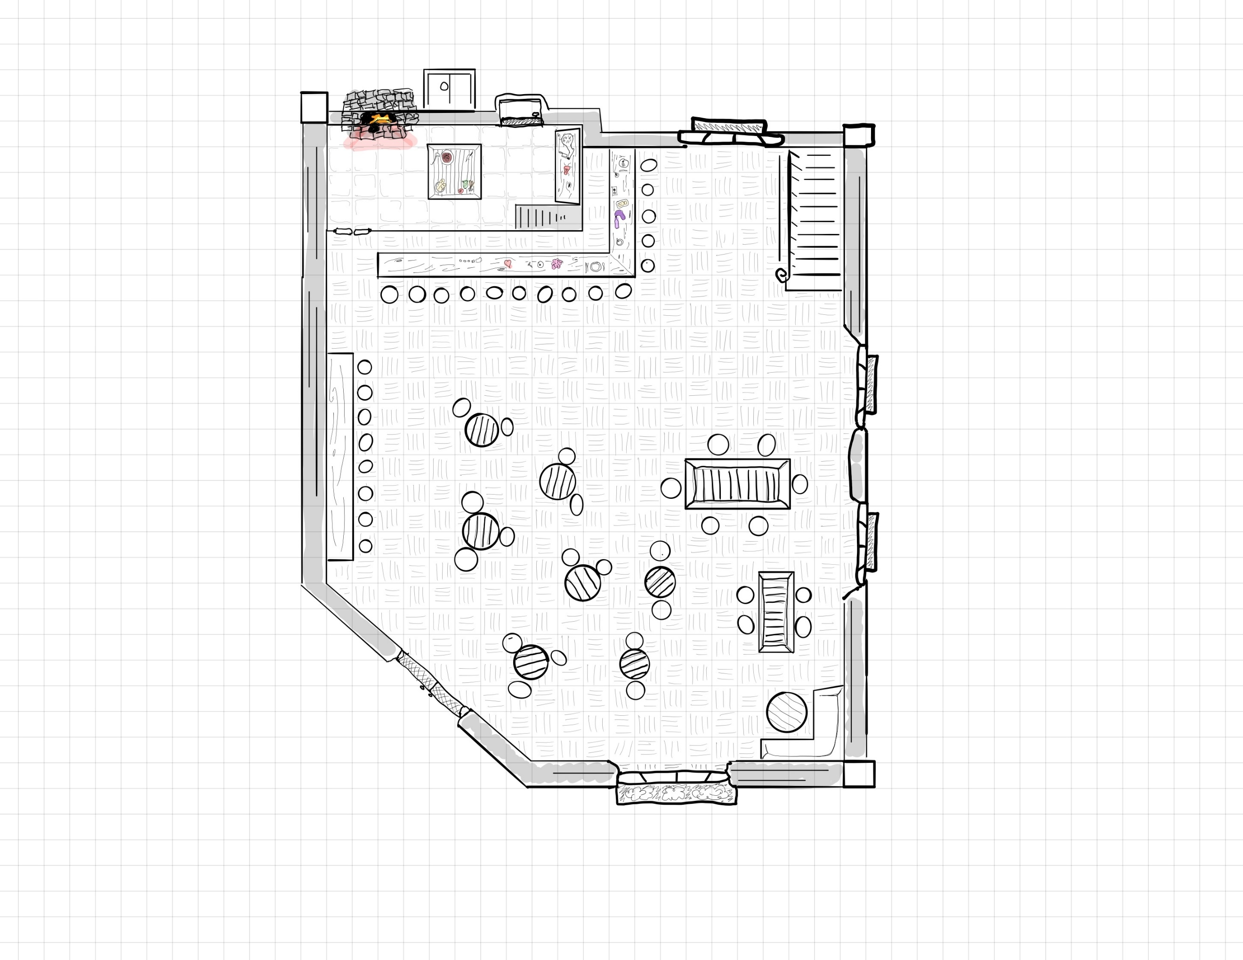

**…and Cellar**

